The rate constants for the IGF – FOXO model

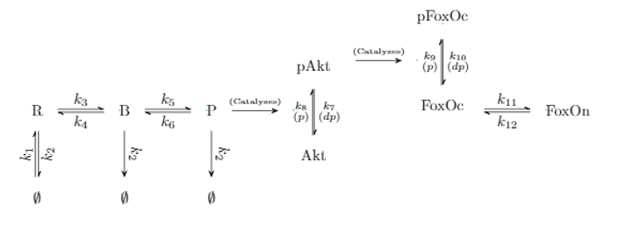

|  |  |  |  |  |
| --- | --- | --- | --- | --- |
| Symbol | Rate of | Value/range | Reference | Unit used in sim |
| K1 | Synthesis of IGFR | UseVal around  0.80576642 pMs-1  Low val = -0.2  Upper limit = 0.2 | The value of 0.8 is what Andrew Used in his simulation | nM s-1 |
| K2 | Degradation of IGFR | Range:  Log10(-4.1 ,-3.1) sec-1 | Taken from Dixit Max Ent paper Degradation of inactive EGFRs  P. D. Dixit, E. Lyashenko, M. Niepel, and D. Vitkup, *Maximum Entropy Framework for Predictive Inference of Cell Population Heterogeneity and Responses in Signaling Networks*, Cell Systems **10**, 204 (2020). | Sec -1 |
| K3 | Binding of IGFR to IGF | 0.000692 nM-1 s-1  2nd ligand binding  0.000346 nM-1 s-1  Log range  -3.5  -3 | Y. Xu, G. K.-W. Kong, J. G. Menting, M. B. Margetts, C. A. Delaine, L. M. Jenkin, V. V. Kiselyov, P. De Meyts, B. E. Forbes, and M. C. Lawrence, *How Ligand Binds to the Type 1 Insulin-like Growth Factor Receptor*, Nat Commun **9**, 821 (2018). Supplementary table 5 |  |
| K4 | Unbinding of IGFR to IGF | 0.0000814 s-1  2nd ligand binding   |  |  | | --- | --- | | 0.0015 s-1 |  |   [-4.8, -2.8] | Y. Xu, G. K.-W. Kong, J. G. Menting, M. B. Margetts, C. A. Delaine, L. M. Jenkin, V. V. Kiselyov, P. De Meyts, B. E. Forbes, and M. C. Lawrence, *How Ligand Binds to the Type 1 Insulin-like Growth Factor Receptor*, Nat Commun **9**, 821 (2018). Supplementary table 5 |  |
| K5 | Phosphorylation of bound receptor | Range  Log10(-0.5, 0.5) s-1 | Taken from max ent paper (Ranges used for EGFR phos)  P. D. Dixit, E. Lyashenko, M. Niepel, and D. Vitkup, *Maximum Entropy Framework for Predictive Inference of Cell Population Heterogeneity and Responses in Signaling Networks*, Cell Systems **10**, 204 (2020). |  |
| K6 | Dephosphorylation of bound receptor | Range  Log10(-1.5, -0.5) | Taken from max ent paper(Ranges used for EGFR dephosph)  P. D. Dixit, E. Lyashenko, M. Niepel, and D. Vitkup, *Maximum Entropy Framework for Predictive Inference of Cell Population Heterogeneity and Responses in Signaling Networks*, Cell Systems **10**, 204 (2020). |  |
| K7 | Dephosphorylation of AKT | Get from before  Log20(-2) , log10( -0.5 ) sec-1 | P. D. Dixit, E. Lyashenko, M. Niepel, and D. Vitkup, *Maximum Entropy Framework for Predictive Inference of Cell Population Heterogeneity and Responses in Signaling Networks*, Cell Systems **10**, 204 (2020). |  |
| K8 | Phosphorylation of AKT | Get from before  Log 10(-0.25) , log10( 1.25) s-1 | P. D. Dixit, E. Lyashenko, M. Niepel, and D. Vitkup, *Maximum Entropy Framework for Predictive Inference of Cell Population Heterogeneity and Responses in Signaling Networks*, Cell Systems **10**, 204 (2020). |  |
| K9 | Phosphorylation of FoxO | Value used by Andrew in the simulation:  k9 = Parameter(name='k9', expression=0.001666667/6000)  ------------------------------  5×10−5 min-1  [-5, -4] | Smith GR, Shanley DP. Modelling the response of FOXO transcription factors to multiple post-translational modifications made by ageing-related signalling pathways. *PLoS One*. 2010;5(6):e11092. Published 2010 Jun 14. doi:10.1371/journal.pone.0011092 |  |
| K10 | Dephosphorylation of FoxO | Value used by Andrew in the simulation:  k10 = Parameter(name='k10', expression=0.000166667)  --------------------  (.5/60) s-1  [-2.3, -1.8] | Smith GR, Shanley DP. Modelling the response of FOXO transcription factors to multiple post-translational modifications made by ageing-related signalling pathways. *PLoS One*. 2010;5(6):e11092. Published 2010 Jun 14. doi:10.1371/journal.pone.0011092 |  |
| K11 | Influx of FoxO to nucleus | Value used by Andrew in the simulation:  k11 = Parameter(name='k11', expression=0.000166667*10)  0.182 min-1  [-2.7, -2.3] | Smith GR, Shanley DP. Modelling the response of FOXO transcription factors to multiple post-translational modifications made by ageing-related signalling pathways. *PLoS One*. 2010;5(6):e11092. Published 2010 Jun 14. doi:10.1371/journal.pone.0011092 |  |
| K12 | Efflux of FoxO from nucleus | Value used by Andrew in the simulation:  k12 = Parameter(name='k12', expression=0.000166667)  0.055 min-1 ~ 9*10^-4 s -1  [-3.5,-2.8] | Smith GR, Shanley DP. Modelling the response of FOXO transcription factors to multiple post-translational modifications made by ageing-related signalling pathways. *PLoS One*. 2010;5(6):e11092. Published 2010 Jun 14. doi:10.1371/journal.pone.0011092 |  |

Paper resource: <https://www.ncbi.nlm.nih.gov/pmc/articles/PMC2886341/>

Question: What is the 2nd ligand binding? Binding of the same ligand to a different site

Check out the How IGF activates its receptors paper : <https://elifesciences.org/articles/03772>

For the influx and efflux rates:

The rates bounds [control, addition of IGF at 20 min for 100 ng/ml]

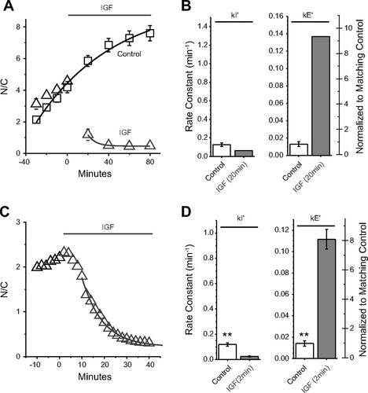

Figure R. J. Wimmer, Y. Liu, T. N. Schachter, D. P. Stonko, B. E. Peercy, and M. F. Schneider, Mathematical Modeling Reveals Modulation of Both Nuclear Influx and Efflux of Foxo1 by the IGF-I/PI3K/Akt Pathway in Skeletal Muscle Fibers, American Journal of Physi

|  |  |  |  |  |
| --- | --- | --- | --- | --- |
| Species | Copy Number | Log Average | Source | Note |
| IGF1R | 5069  20300 | 10144 | Deep proteome and transcriptome mapping of a human cancer cell line  An Optimized Shotgun Strategy for the Rapid Generation of Comprehensive Human Proteomes | Supplimentary File 7 row 5635  Supplimentary File S4 row 876 |
| Akt1 | 26,654  43,500 | 34050 | Deep proteome and transcriptome mapping of a human cancer cell line  An Optimized Shotgun Strategy for the Rapid Generation of Comprehensive Human Proteomes | Supplimentary File 7 row 3,489  Supplimentary File S4 row 4,628 |
| Akt2 | 18,700  73,500 | 37073 | Deep proteome and transcriptome mapping of a human cancer cell line  An Optimized Shotgun Strategy for the Rapid Generation of Comprehensive Human Proteomes | Supplimentary File 7 row 3,975  Supplimentary File S4 row 4,629 |
| FoxO1 | 710 | 710 | An Optimized Shotgun Strategy for the Rapid Generation of Comprehensive Human Proteomes | Supplimentary File S4 row 6,278 |